Multimodal Radiology Diagnosis Pipeline

Presented By
Ethan Saline

Background
This project is a proof of concept for a larger integration of machine learning into the medical systems of hospitals. The goal is to create a pipeline that takes an X-ray image and can not only create a report and diagnose the illness but also show on the X-ray itself where the model is looking when making the diagnosis, so that it can be verified by a human in the loop before any decisions are made.
For this project the data from MIMIC-CXR is used which provides around 377,000 images and radiology reports. Due to hardware limitations the images are not stored permanently, and only 1200 reports are used at the time of this report with a goal of at least 5000. The model is fed 200 new X-rays and reports weekly and partially retrains itself Sunday at midnight, simulating real hospitals’ influx of data from current patients.
The model will be implemented directly into the most common US Hospital system to be used directly in the work environment.

Methodology
The pipeline runs as a weekly automated DAG pulling chest X-rays from MIMIC-CXR. It processes each study through five sequential steps:
- Encode: BioViL encodes each DICOM into a 128-dim image embedding
- Retrieve: FAISS searches for the 5 most similar historical studies (Recall@5: 89.7% currently at 1200 studies)
- Report: BioViL-T generates findings and impression text from the image embedding and retrieved cases
- Diagnose: A CNN classifier receives the concatenated image + report embedding (256-dim) and outputs per-pathology probabilities
- Validate: Grad-CAM heatmaps are generated for clinical interpretability and outputs are persisted to PostgreSQL
Storage layers: FAISS holds image embeddings, PostgreSQL is the source of truth, and Redis provides a hot cache with a 7-day TTL.
Uncertainty Label Strategy

Condition | Strategy | Reason
All conditions (default) | U-Ones → 1 | Clinically safer. False negatives are more harmful than false positives.
Cardiomegaly and Atelectasis | U-Zeroes → 0 | Uncertain cases trend negatively historically in CheXpert.

Architecture

Step | Script | Input | Output
1 | get_data.py | MIMIC-CXR PhysioNet | DICOMs in data/raw
2 | label_data.py | data/raw DICOMs | manifest.csv appended
3 | ingest.py | manifest.csv | Studies + labels in PostgreSQL
4 | encode.py | data/raw DICOMs | Embeddings in FAISS, DICOMs deleted
5 | retrieve.py | Image embedding | Top-5 similar cases with reports
6 | report.py | Embedding + retrieved cases | Findings + impression + report embedding
7 | diagnose.py | Image embedding (128) + report embedding (128) | Per-pathology probabilities
8 | train_classifier.py | All embeddings + labels | Updated CNN weights saved
9 | validate.py | All outputs | Heatmaps + final JSON to PostgreSQL

Results
Example Output: Each study produces a single JSON object written to the PostgreSQL outputs table:
{ "findings": "Mild atelectasis at the left base...", "impression": "No acute cardiopulmonary process.", "diagnoses": { "pneumonia": 0.83, "effusion": 0.11 }, "confidence": 0.91}
Below is a generated heatmap of a nonprotected Kaggle X-ray
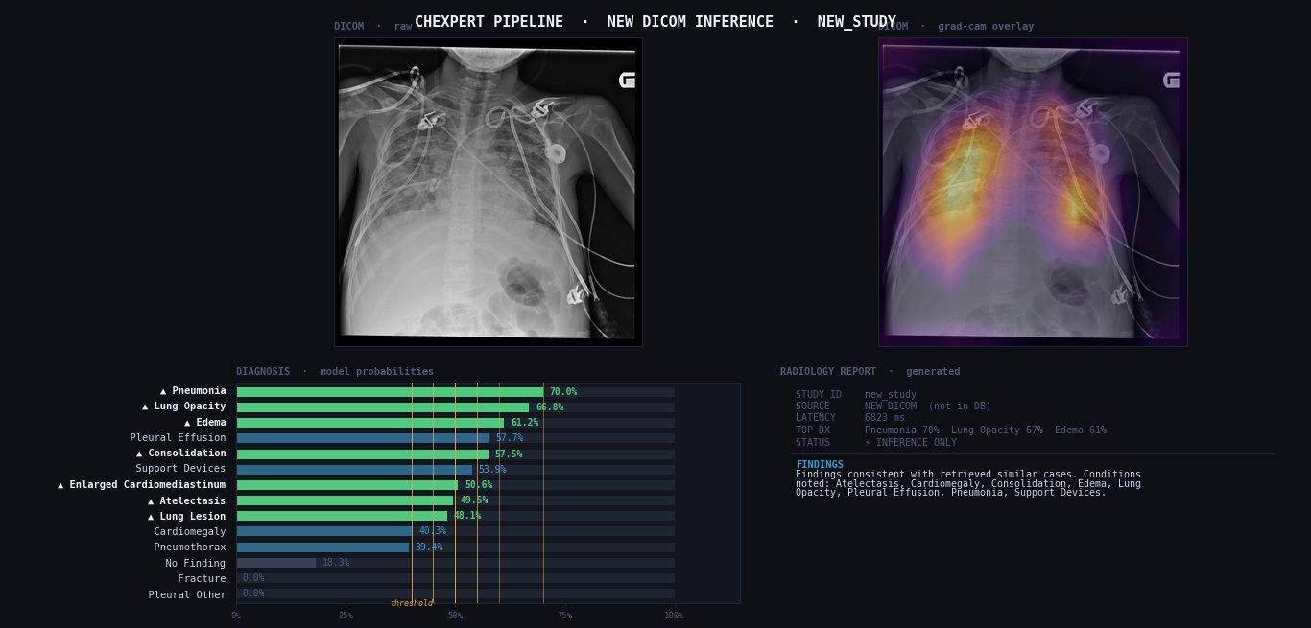
Note: The X-ray above has been correctly diagnosed with pneumonia by both a doctor and the model
Current AUROCs (per 1200 studies):
- Strong conditions (Pneumonia, Edema, Consolidation): 0.72 – 0.82
- Retrieval Recall@5: 89.7% ✓
- Inference latency: < 2 seconds per study
- Pipeline retrains automatically each week as new data accumulates

Future Developement
- Scale to 5,000+ studies: Expected to push AUROC above 0.85 across all conditions. There are 377k studies available, 5000 is the minimum to achieve hospital ready confidence
- U-Train uncertainty label strategy: Replace current U-Ones/U-Zeroes strategies with self-trained uncertainty handling for improved label quality
- Epic / FHIR integration: Connect the pipeline directly to the EHR so reports and diagnoses surface within the clinical workflow without manual export

